**CENWP-OD-J September 8, 2022**

**MEMORANDUM FOR THE RECORD**

**SUBJECT: 22JDA12 Spillbays 1-4 Out of Service for Routine Inspection**

At approximately 0630 on Thursday September 8, 2022, John Day Project spillbays 1-4 were taken offline to perform scheduled inspections. The work required personnel to rappel onto the tainter gates on the downstream side of the spillbays for the inspection. Per the contract’s safety requirements, the adjacent gates were required to be closed for safety concerns.

Following requirements in the Fish Passage Plan, bay-2 is to be opened to 1-stop (~1.6 kcfs) for north fish ladder (NFL) attraction flows from 15 August to 30 November. In place of bay-2 (or any bays 1-4) the John Day Project spilled through bay-5 (1-stop, ~1.6 kcfs) for NFL attraction water. Spill bay 2 was tagged out for approximately 6 hours from 0630 - 1230 and spill bay 5 was used for attraction in-lieu of the closure of bay 2 due to the inspections. Once the inspection was completed spill bay 2 was returned to service at 1230.

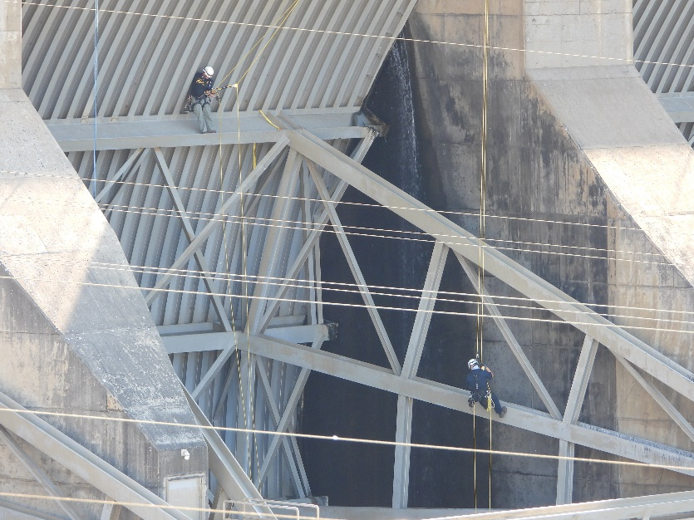

Figure 1: An inspection of the tainter gate at spillbay #3 (Note: the horizontal lines are not associated with the inspection; they are avian lines).

**Resolution:**

1. Species- N/A
2. Origin – N/A
3. Length – N/A
4. Marks and tags – N/A
5. Marks and Injuries found on carcass – N/A
6. Cause and Time of Death – N/A
7. Future and Preventative Measures – Request an edit to the FPP to include this routine maintenance. An FPP change form will be submitted.

Sincerely,

JD Project Fisheries